High Performance Computing Lab
Practical No. 6
PRN: 22510078
Name: Piyush Krishna Jadhav
Batch: B5

Title of practical:
Installation of MPI & Implementation of basic functions of MPI

Problem Statement 1:
Implement a simple hello world program by setting number of processes equal to 10.

Code :
#include <mpi.h>
#include <stdio.h>

int main(int argc, char** argv) {
// Initialize MPI environment
MPI_Init(&argc, &argv);

// Get the number of processes
int world_size;
MPI_Comm_size(MPI_COMM_WORLD, &world_size);

// Get the rank (ID) of this process
int world_rank;
MPI_Comm_rank(MPI_COMM_WORLD, &world_rank);

printf("Hello World from process %d out of %d processes\n", world_rank, world_size);

MPI_Finalize();
return 0;
}

Screenshots:
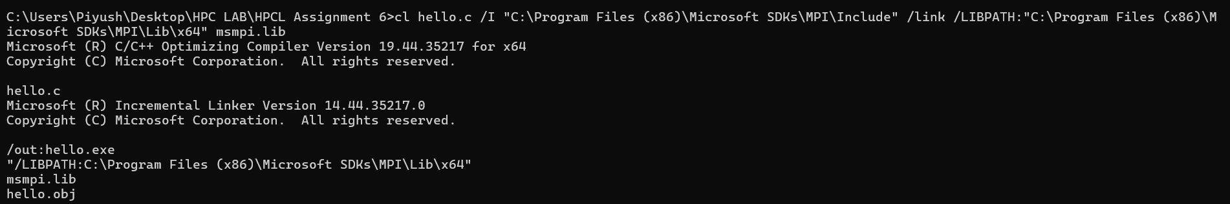
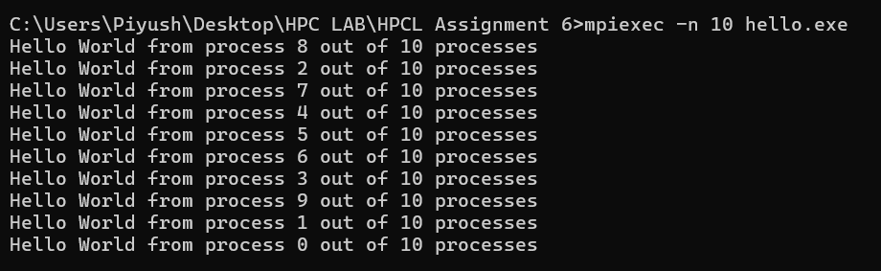

Information 1:
Introduction to MPI:
MPI (Message Passing Interface) is a standard library for parallel programming in distributed computing environments. It allows multiple processes to communicate and coordinate their execution by sending and receiving messages. MPI is widely used in High-Performance Computing (HPC) to solve computationally intensive problems efficiently by dividing tasks among multiple processors.
Aim of the Practical:
- To implement a simple Hello World program using MPI.
- To execute the program with 10 parallel processes.
- To observe how MPI processes operate concurrently and print their messages.
Working of the Program:
- MPI environment is initialized using MPI_Init.
- Each process identifies its rank and the total number of processes using MPI_Comm_rank and MPI_Comm_size.
- Each process prints a message:
"Hello World from process X out of Y processes".
- MPI environment is finalized with MPI_Finalize.
Observations:
- Each line corresponds to one process printing its message.
- process X shows the rank (ID) of the process.
- out of 10 processes indicates the total number of processes.
- The order of the messages is random because all processes run in parallel. This demonstrates concurrent execution in MPI.

Problem Statement 2:
Implement a program to display rank and communicator group of five processes

Code :
#include <mpi.h>
#include <stdio.h>

int main(int argc, char **argv)
{
MPI_Init(&argc, &argv);

// Get total number of processes
int world_size;
MPI_Comm_size(MPI_COMM_WORLD, &world_size);

// Get rank of this process
int world_rank;
MPI_Comm_rank(MPI_COMM_WORLD, &world_rank);

// Get communicator group
MPI_Group group;
MPI_Comm_group(MPI_COMM_WORLD, &group);

printf("Process %d out of %d processes in communicator group\n", world_rank, world_size);

MPI_Finalize();
return 0;
}

Screenshots:
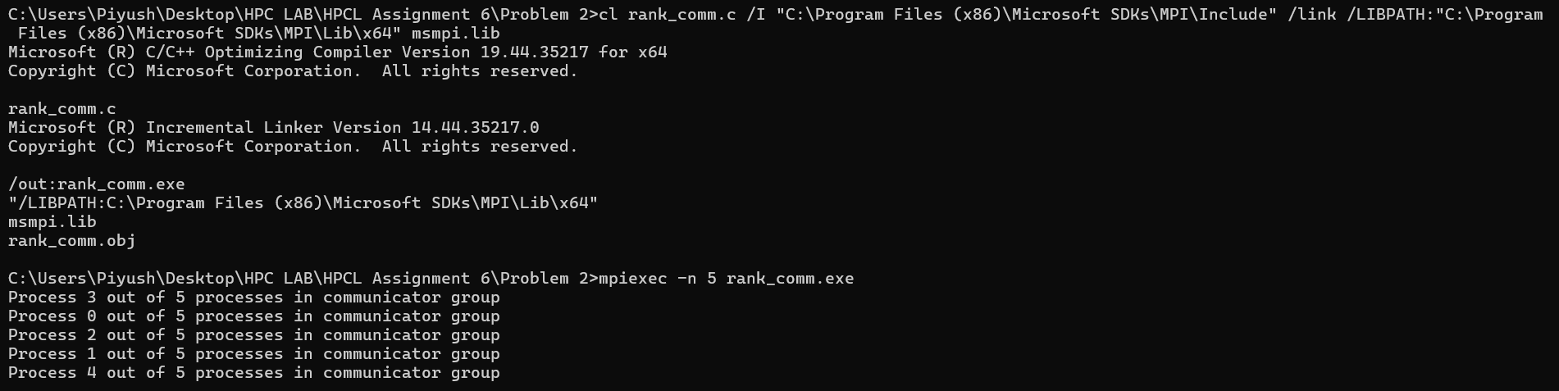
Information :
Number of Processes: 5
MPI Functions Used:
- MPI_Init(&argc, &argv); → initialize MPI.
- MPI_Comm_size(MPI_COMM_WORLD, &world_size); → total processes.
- MPI_Comm_rank(MPI_COMM_WORLD, &world_rank); → rank of this process.
- MPI_Comm_group(MPI_COMM_WORLD, &group); → get communicator group.
- MPI_Finalize(); → finalize MPI.
Observations:
- Each process prints its rank and confirms its membership in MPI_COMM_WORLD.
- Parallel execution causes the output order to vary each run.

Q3: Implement a MPI program to give an example of Deadlock.
Program and screenshots.
Code :
#include <mpi.h>
#include <stdio.h>

int main(int argc, char** argv) {
MPI_Init(&argc, &argv);

int rank, size;
MPI_Comm_rank(MPI_COMM_WORLD, &rank);
MPI_Comm_size(MPI_COMM_WORLD, &size);

int msg;
if (size < 2) {
if (rank == 0) printf("Need at least 2 processes for this example.\n");
MPI_Finalize();
return 0;
}

if (rank == 0) {
// Process 0 tries to receive first, then send
MPI_Recv(&msg, 1, MPI_INT, 1, 0, MPI_COMM_WORLD, MPI_STATUS_IGNORE);
printf("Process 0 received message from Process 1\n");
MPI_Send(&msg, 1, MPI_INT, 1, 0, MPI_COMM_WORLD);
} else if (rank == 1) {
// Process 1 tries to receive first, then send
MPI_Recv(&msg, 1, MPI_INT, 0, 0, MPI_COMM_WORLD, MPI_STATUS_IGNORE);
printf("Process 1 received message from Process 0\n");
MPI_Send(&msg, 1, MPI_INT, 0, 0, MPI_COMM_WORLD);
}

MPI_Finalize();
return 0;
}

Screenshots:
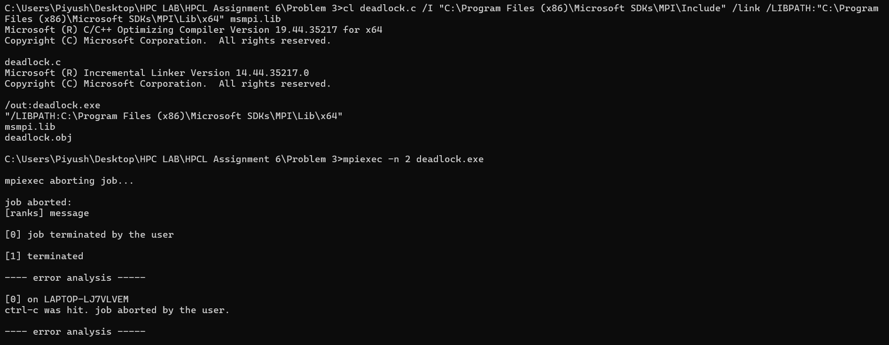

Q4. Implement blocking MPI send & receive to demonstrate Nearest neighbor exchange of data in a ring topology.
Program and screenshots.
Code :
#include <mpi.h>
#include <stdio.h>

int main(int argc, char** argv) {
MPI_Init(&argc, &argv);

int rank, size;
MPI_Comm_rank(MPI_COMM_WORLD, &rank);
MPI_Comm_size(MPI_COMM_WORLD, &size);

int send_data = rank; // Each process sends its own rank
int recv_data = -1;

int next = (rank + 1) % size; // Next neighbor in ring
int prev = (rank - 1 + size) % size; // Previous neighbor in ring

// Blocking send & receive
MPI_Send(&send_data, 1, MPI_INT, next, 0, MPI_COMM_WORLD);
MPI_Recv(&recv_data, 1, MPI_INT, prev, 0, MPI_COMM_WORLD, MPI_STATUS_IGNORE);

printf("Process %d received %d from process %d\n", rank, recv_data, prev);

MPI_Finalize();
return 0;
}

Screenshots:
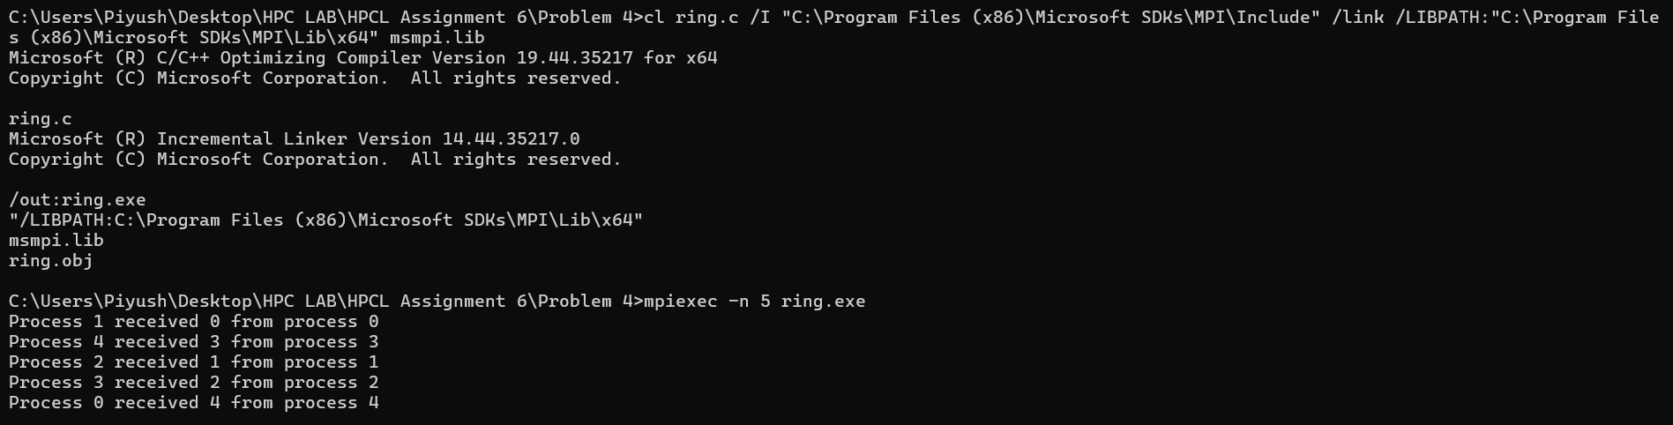

Q5. Write a MPI program to find the sum of all the elements of an array A of size
n. Elements of an array can be divided into two equals groups. The first [n/2]
elements are added by the first process, P0, and last [n/2] elements the by second process, P1. The two sums then are added to get the final result.
Program and screenshots.

Code :
#include <mpi.h>
#include <stdio.h>

int main(int argc, char** argv) {
MPI_Init(&argc, &argv);

int rank;
MPI_Comm_rank(MPI_COMM_WORLD, &rank);

int n = 10; // Size of the array
int A[10] = {1,2,3,4,5,6,7,8,9,10}; // Example array
int local_sum = 0;

if (rank == 0) {
// Sum first half
for (int i = 0; i < n/2; i++) {
local_sum += A[i];
}
// Send local sum to process 1
MPI_Send(&local_sum, 1, MPI_INT, 1, 0, MPI_COMM_WORLD);
} else if (rank == 1) {
// Sum second half
for (int i = n/2; i < n; i++) {
local_sum += A[i];
}
int sum0;
// Receive sum from process 0
MPI_Recv(&sum0, 1, MPI_INT, 0, 0, MPI_COMM_WORLD, MPI_STATUS_IGNORE);
int total_sum = sum0 + local_sum;
printf("Total sum of array elements = %d\n", total_sum);
}

MPI_Finalize();
return 0;
}

Screenshots :
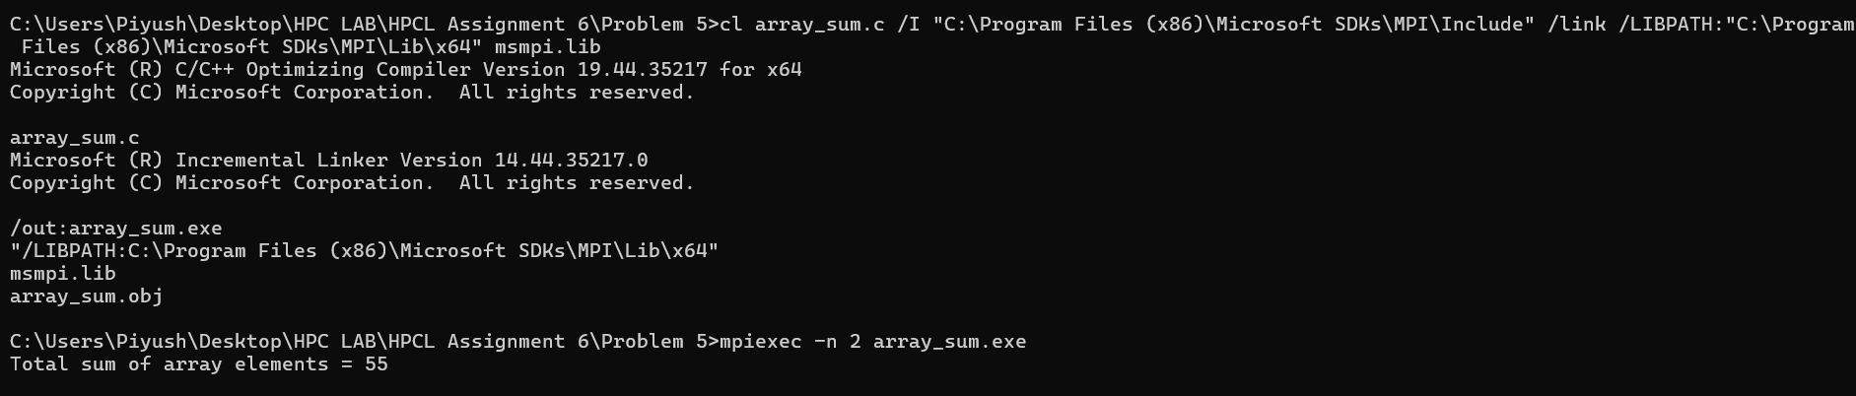

Information:
MPI allows multiple processes to work together for faster computation. In this practical, we use 2 processes to calculate the sum of an array in parallel.
Working of the Program:
- An array A = {1,2,3,4,5,6,7,8,9,10} is divided into two halves.
- Process 0 sums the first half (1–5) → 15.
- Process 1 sums the second half (6–10) → 40.
- Process 0 sends its sum to Process 1.
- Process 1 adds both sums → total sum = 55 and prints it.
Observations:
- Each process works independently on its portion.
- MPI ensures proper communication and aggregation of partial results.
- Output is 55 because 1+2+3+4+5 + 6+7+8+9+10 = 55.

